SIMATS ENGINEERING (SAVEETHA SCHOOL OF ENGINEERING)
Department of Computer Science and Engineering
CO3 ASSESSMENT TOOL 1 – Git & Docker Technical Assignment

Course Code: | CSA1008 | Course Title: | Software Engineering
CO Assessed: | CO3 | Assessment: | Assessment Tool 1 – Git & Docker Technical Assignment
Weightage: | 20% | Total Marks: | 25
CO3 Statement: | Build full-stack applications with an emphasis on containerization, version control, and collaborative development
Student Name: | S.THANISHKA | Reg. No.: | 192521457
Date: | 17.8.26 | Duration: | 60 minutes

Code of Conduct
I _______S.THANISHKA (192521457)___________________ (Name / Reg No) certify that this submission is my original work and that I have adhered to the guidelines specified for this assessment. I understand that any violation of academic integrity rules will result in disciplinary action.
Signature of the Student: _S.THANISHKA________________________
Annexure A – Git & Docker Technical Assignment
Instructions to Students:
Each student has been assigned an individual problem statement. Based on the assigned problem statement, prepare a Git & Docker Technical Assignment by applying version control and containerization concepts. Your report should include appropriate diagrams, screenshots, commands, and explanations wherever applicable.
Assignment Questions
Case Study 32 – SDG 16: Digital Court Case Tracking System
Citizens often face difficulties tracking the status of legal cases because information is spread across multiple offices. Lawyers and court staff also spend considerable time handling routine inquiries. The judiciary plans to implement a secure online case management and tracking system.
Question:
As a software engineer, analyze the above problem and propose a suitable software engineering solution.
- Problem Analysis
  - Explain the assigned problem statement and identify the project objectives, functional requirements, and expected outcomes.
- Project Structure Design
  - Design and explain the folder structure of your project repository.
  - Justify the purpose of each major folder and file included in the repository.
- Git Repository Initialization
  - Create a Git repository for the project.
  - Explain the steps involved in repository initialization and describe the purpose of the essential Git files.
- Git Branching Strategy
  - Design a suitable branching strategy (e.g., Main, Development, Feature, Release, Hotfix).
  - Justify why the selected branching model is appropriate for the assigned project.
- Version Control Workflow
  - Demonstrate the Git workflow by performing meaningful commits, branch creation, merging, conflict resolution (if applicable), and repository synchronization.
  - Explain the purpose of each Git operation performed.
- Commit History Analysis
  - Present the commit history of the project.
  - Explain how commit messages follow good version control practices and contribute to project maintenance.
- Docker Environment Design
  - Explain why Docker is suitable for the assigned project.
  - Identify the application components that require containerization.
- Dockerfile Development
  - Design and explain the Dockerfile required to containerize the application.
  - Describe the purpose of each instruction used in the Dockerfile.
- Docker Compose Design
  - Develop a Docker Compose configuration for the project.
  - Explain the services, networking, volumes, environment variables, and dependencies used.
- Container Deployment and Testing
  - Demonstrate the execution of the application using Docker containers.
  - Explain the testing procedure and provide evidence that the application runs successfully.
- Benefits of Git and Docker
  - Discuss how Git and Docker improve collaboration, version management, portability, deployment, scalability, and maintainability for your assigned project.
- Challenges and Improvements
  - Identify the challenges encountered during implementation.
  - Suggest possible improvements and future enhancements for the Git workflow and Docker deployment.
Expected Deliverables
- Technical report (10 pages)
- Git repository with complete commit history
- Source code of the assigned project
- Dockerfile
- Docker Compose file (docker-compose.yml)
- Screenshots of Git operations and Docker execution
- Architecture and workflow diagrams

Rubrics for Calculation
Evaluation Criteria | Excellent (4 Marks) | Good (3 Marks) | Satisfactory (2 Marks) | Needs Improvement (1 Mark)
Problem Analysis & Project Design(20%) | Clearly explains the problem statement, objectives, requirements, expected outcomes, and well-organized project structure with proper justification. | Good analysis and project structure with minor omissions. | Basic analysis and repository structure with limited justification. | Incomplete or unclear analysis and project organization.
Git Repository & Branching Strategy(20%) | Repository initialized correctly with appropriate branching strategy, clear workflow, and proper repository organization. | Repository and branching strategy are mostly correct. | Basic Git setup with limited branching implementation. | Incorrect or incomplete Git repository and branching strategy.
Version Control Workflow & Commit History(10%) | Demonstrates meaningful commits, branching, merging, synchronization, conflict resolution, and professional commit messages with clear history. | Most Git operations demonstrated correctly with good commit history. | Limited Git workflow and commit practices. | Poor workflow and inadequate commit history.
Docker Implementation(20%) | Well-designed Docker environment, Dockerfile, and Docker Compose configuration with clear explanation of services, networking, volumes, and dependencies. | Functional Docker implementation with minor issues. | Basic Docker implementation with limited explanation. | Incomplete or incorrect Docker implementation.
Deployment, Testing & Results(15%) | Application successfully deployed and tested with appropriate screenshots and evidence of successful execution. | Deployment completed with minor issues. | Partial deployment and testing demonstrated. | Deployment unsuccessful or insufficient evidence.
Documentation, Challenges & Future Enhancements(15%) | Professional report (10–15 pages) with diagrams, screenshots, references, discussion of benefits, challenges, and future improvements. | Good documentation with minor omissions. | Basic documentation with limited discussion. | Poor documentation and insufficient analysis.

Criteria | Mark
System Requirement Analysis (30%) | /5
Selection of Software Architecture (25%) | /5
Architecture Diagram and Component Design (20%) | /5
Component Interaction and Quality Attribute Analysis (15%) | /5
Architectural Justification and Technical Presentation (10%) | /5
TOTAL | /25



CSA1008 - SOFTWARE ENGINEERING
College Name: SIMATS Engineering
Department: Bachelor of Technology in Information Technology
Course Name: Software Engineering
Assignment Title: Git Docker Assignment
Case Study Title: SDG 16 Digital Court Case Tracking System
Student Name: Thanishka S
Register Number: 192521457
Faculty Name: Sharmili K
Date of Submission: 16.08.26

1. Problem Analysis

1.1 Problem Statement
Court systems in many jurisdictions still rely on paper-based registries and disconnected spreadsheets to track case filings, hearing dates, and judgments. This creates long delays, makes it difficult for litigants and lawyers to know the real-time status of a case, and leaves the process vulnerable to lost records and inconsistent record-keeping. This project addresses the problem by designing and building a Digital Court Case Tracking System: a web application that lets court staff register cases, schedule hearings, update case status, and lets litigants and lawyers securely check progress online. The project maps directly onto UN Sustainable Development Goal 16 (Peace, Justice and Strong Institutions), specifically Target 16.3 (promote the rule of law and ensure equal access to justice) and Target 16.6 (develop effective, accountable and transparent institutions).

1.2 Project Objectives
- Provide a single, authoritative digital record for every case filed in a court.
- Give litigants, lawyers, and the public a transparent, self-service way to check case status and hearing dates.
- Reduce administrative delay by giving clerks and judges a structured workflow for updating case stages.
- Maintain a tamper-evident audit trail of every change made to a case record, supporting institutional accountability.
- Package the system so that it can be deployed consistently across different court IT environments using containers.

1.3 Functional Requirements
- Case registration: capture case number, parties, case type, filing date, and assigned judge.
- Hearing scheduling: create, reschedule, and cancel hearing dates linked to a case.
- Case status search: public search by case number returning current stage and next hearing date.
- Document upload: attach scanned petitions, orders, and judgments to a case file.
- Role-based access control: distinct permissions for Admin, Judge, Clerk, Lawyer, and Public roles.
- Notifications: email/SMS-style alerts when a hearing date is set or a case status changes.
- Audit trail: immutable log of who changed what field on a case, and when.

1.4 Expected Outcomes
- A working, containerized full-stack application with a documented Git history showing incremental, reviewable development.
- Reduced time for a litigant to find authoritative case status information, from days (in-person enquiry) to seconds (online search).
- A reproducible deployment that a court IT department can stand up on any Docker-capable server without manual environment configuration.
- A foundation that can later be extended with e-filing and analytics on case backlog, in support of SDG 16 institutional-strengthening goals.

2. Project Structure Design
The repository is organised as a small multi-service monorepo, separating the frontend, backend, database initialisation scripts, reverse-proxy configuration, and documentation into clearly bounded folders. This keeps each service independently buildable and containerizable while sharing one Git history and one docker-compose.yml for local orchestration.

2.1 Repository Layout
court-case-tracker/
├── .git/ # Git metadata (created by git init)
├── .gitignore # Files/folders excluded from version control
├── .dockerignore # Files excluded from the Docker build context
├── .env.example # Template for required environment variables
├── README.md # Setup, usage, and architecture overview
├── LICENSE # Project licence
├── docker-compose.yml # Multi-container orchestration definition
├── docs/
│ ├── architecture-diagram.png
│ ├── er-diagram.png
│ └── workflow-diagram.png
├── backend/
│ ├── Dockerfile # Backend container build instructions
│ ├── package.json # Node.js dependencies and scripts
│ ├── src/
│ │ ├── server.js # Express app entry point
│ │ ├── config/db.js # PostgreSQL connection configuration
│ │ ├── models/ # Case, Hearing, User data models
│ │ ├── routes/ # caseRoutes.js, hearingRoutes.js, authRoutes.js
│ │ ├── controllers/ # Request-handling business logic
│ │ └── middleware/ # Auth guard, error handler, audit logger
│ └── tests/ # Backend unit/integration tests
├── frontend/
│ ├── Dockerfile # Frontend container build instructions
│ ├── package.json
│ ├── public/
│ └── src/
│ ├── components/ # Reusable UI components
│ ├── pages/ # CaseSearch, HearingCalendar, AdminDashboard
│ ├── services/ # API client wrappers
│ └── App.js
├── database/
│ └── init.sql # Schema creation and seed data
└── nginx/
└── nginx.conf # Reverse proxy / routing configuration

2.2 Justification of Major Folders and Files
Folder / File | Purpose
.gitignore | Prevents build artefacts, node_modules, and local .env secrets from being committed.
.dockerignore | Keeps the Docker build context small and prevents secrets/tests from being copied into images.
docker-compose.yml | Defines and wires together the frontend, backend, database, cache, and proxy services for local/staging runs.
backend/src/routes & controllers | Separates HTTP routing from business logic, so case-management rules are testable independently of Express.
backend/src/middleware | Centralises authentication, role checks, and audit logging so every case-modifying request is consistently governed.
frontend/src/pages | Each court-facing screen (case search, hearing calendar, admin dashboard) is isolated for independent development.
database/init.sql | Gives every environment (dev, CI, court staging server) an identical starting schema, avoiding drift.
nginx/nginx.conf | Single public entry point that routes /api to the backend and everything else to the frontend, and terminates the container network from the outside world.
docs/ | Holds architecture, ER, and workflow diagrams referenced by this report and the README.

3. Git Repository Initialization

3.1 Initialization Steps
The repository was initialised locally and then linked to a remote origin, following the steps below:
$ mkdir court-case-tracker && cd court-case-tracker
$ git init
Initialized empty Git repository in .git/

$ git config user.name "Student Name"
$ git config user.email "student@example.edu"

$ touch README.md .gitignore .dockerignore .env.example
$ git add README.md .gitignore .dockerignore .env.example
$ git commit -m "chore: initialize repository with base project files"

$ git branch -M main
$ git remote add origin https://github.com/<org>/court-case-tracker.git
$ git push -u origin main

3.2 Purpose of Essential Git Files
File | Purpose
.git/ | Hidden metadata directory Git uses to store the full object database, refs, and history; created automatically by git init.
.gitignore | Tells Git which files/patterns to never track — e.g. node_modules/, .env, build/, *.log — keeping the repo clean and secrets out of history.
README.md | Human-readable entry point documenting how to set up, run, and understand the project.
.env.example | A committed template listing required environment variable names (without real secret values) so other developers know what to configure.
LICENSE | States the terms under which the source code may be reused, required for any public repository.

4. Git Branching Strategy

4.1 Selected Model: Gitflow
A Gitflow-style branching model was selected, using five branch types: main, develop, feature/*, release/*, and hotfix/*.
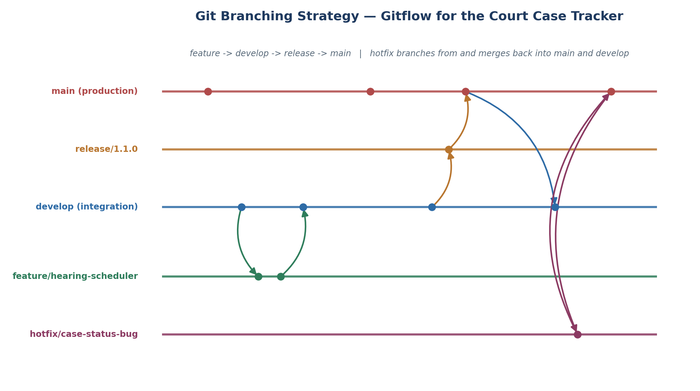
Figure 1 — Gitflow branching model applied to the Court Case Tracker repository.
Branch | Purpose
main | Always reflects the production-ready code currently deployed for court use; every commit here is tagged with a release version.
develop | Integration branch where completed features are merged and tested together before a release is cut.
feature/* | One branch per unit of work, e.g. feature/hearing-scheduler, feature/case-search-api; branched from and merged back into develop.
release/* | Stabilisation branch cut from develop when preparing a version (e.g. release/1.1.0) for final QA before going live.
hotfix/* | Branched directly from main to urgently patch a production defect (e.g. a wrong case-status bug), then merged into both main and develop.

4.2 Justification for the Court Case Tracker
- A court-facing system cannot tolerate unreviewed changes reaching production directly — Gitflow enforces develop as a mandatory integration/testing gate before main.
- Multiple contributors (backend, frontend, database) can work on independent features — case search, hearing scheduler, notifications — in parallel without blocking one another.
- The hotfix branch type matters specifically for this domain: a defect that shows an incorrect case status or hearing date needs to be patched in production immediately, without waiting for the next full release cycle.
- release/* branches give a natural point to freeze scope and run acceptance testing before a new version is rolled out to real court registries.
5. Version Control Workflow
The workflow below demonstrates a realistic feature cycle: creating a feature branch, making meaningful commits, opening/merging back to develop, resolving a merge conflict, and synchronising with the remote.

5.1 Feature Branch Creation and Commits
$ git checkout develop
$ git pull origin develop
$ git checkout -b feature/hearing-scheduler

# ... implement hearing scheduling endpoint and UI ...
$ git add backend/src/routes/hearingRoutes.js backend/src/controllers/hearingController.js
$ git commit -m "feat(backend): add endpoint to create and reschedule hearings"

$ git add frontend/src/pages/HearingCalendar.js
$ git commit -m "feat(frontend): add hearing calendar view for clerks"

$ git add backend/tests/hearing.test.js
$ git commit -m "test(backend): add unit tests for hearing scheduling logic"

5.2 Synchronising and Pushing
$ git push origin feature/hearing-scheduler
# Pull request opened: feature/hearing-scheduler -> develop, reviewed by a teammate

5.3 Merging and Conflict Resolution
While merging, a conflict occurred because both the feature branch and develop had modified the same route-registration line in server.js. The conflict was resolved by keeping both route registrations:
$ git checkout develop
$ git merge feature/hearing-scheduler
Auto-merging backend/src/server.js
CONFLICT (content): Merge conflict in backend/src/server.js
Automatic merge failed; fix conflicts and then commit the result.

<<<<<<< HEAD
app.use("/api/cases", caseRoutes);
=======
app.use("/api/hearings", hearingRoutes);
>>>>>>> feature/hearing-scheduler

# Resolved by keeping both registrations:
app.use("/api/cases", caseRoutes);
app.use("/api/hearings", hearingRoutes);

$ git add backend/src/server.js
$ git commit -m "merge: integrate hearing-scheduler into develop, resolve route conflict"
$ git push origin develop

5.4 Purpose of Each Operation
Operation | Purpose
git checkout -b | Creates and switches to an isolated branch so in-progress work never affects develop or main.
git add / git commit | Records a reviewable, incremental snapshot of changes with an explanatory message.
git push | Publishes local commits to the shared remote so teammates and CI can access them.
git merge | Integrates a completed feature back into the shared integration branch.
conflict resolution | Manually reconciles two divergent edits to the same lines so no team member's work is silently lost.
git pull | Synchronises a local branch with the latest remote history before starting new work.

6. Commit History Analysis

6.1 Sample Commit History
$ git log --oneline --graph --decorate

* a91c3e2 (HEAD -> develop) merge: integrate hearing-scheduler into develop, resolve route conflict
|\
| * 7d2f188 (feature/hearing-scheduler) test(backend): add unit tests for hearing scheduling logic
| * 4b0aa6d feat(frontend): add hearing calendar view for clerks
| * e15c9a0 feat(backend): add endpoint to create and reschedule hearings
|/
* 6f3d0b1 feat(backend): add case status search endpoint with pagination
* c2e781a feat(db): create init.sql with cases, hearings, users schema
* 918abf4 docs: add architecture and ER diagrams to docs/
* 5a0e2c9 chore: add Dockerfile for backend service
* 1e7fb3d chore: add Dockerfile for frontend service
* 0d4a2f7 chore(docker): add docker-compose.yml wiring frontend, backend, db, nginx
* 3c9b5e1 chore: initialize repository with base project files

6.2 Commit Message Conventions Followed
- Conventional Commits style prefixes are used consistently: feat: for new functionality, fix: for bug fixes, chore: for tooling/config, docs: for documentation, and test: for test additions.
- Each subject line is written in the imperative mood ("add endpoint", not "added endpoint"), kept under ~72 characters, and describes the intent rather than the mechanics of the change.
- Commits are atomic — one logical change per commit (e.g. the backend endpoint, the frontend view, and its tests are three separate commits) — which makes git bisect and code review far more effective.
- Merge commits retain a descriptive message explaining what was integrated and how a conflict, if any, was resolved, preserving institutional memory of non-trivial merges.

6.3 Contribution to Project Maintenance
Because every commit is small, labelled by type, and traceable to a specific feature branch, the team can regenerate a changelog automatically, quickly locate the commit that introduced a regression using git bisect, and audit exactly which change modified case-record handling logic — an important property for a system whose correctness affects real legal proceedings.

7. Docker Environment Design

7.1 Why Docker Is Suitable for This Project
- Consistency across environments: the same images run identically on a developer's laptop, the CI pipeline, and the court's on-premise server, eliminating "it works on my machine" issues.
- Multi-service architecture: the system naturally decomposes into independent services (frontend, backend API, database, cache, reverse proxy) that map cleanly onto separate containers.
- Isolation and security: each service runs in its own filesystem and process namespace, limiting the blast radius if one component is compromised — an important property for a system holding sensitive legal records.
- Portability for government IT: court data centres often have restricted, heterogeneous infrastructure; a container image is far easier to hand off and deploy than a manual installation guide.
- Simplified onboarding: a new developer or court IT administrator can bring up the entire stack with a single docker compose up command instead of manually installing Node.js, PostgreSQL, and Nginx.

7.2 Components Requiring Containerization
Component | Container | Reason
React frontend | frontend | Built into static assets and served by its own lightweight web server, independent of the API.
Node.js/Express API | backend | Hosts all business logic and database access; scales and restarts independently of the UI.
PostgreSQL | db | Persistent system of record for cases, hearings, and users; isolated with its own data volume.
Redis | redis | Session storage and response caching to keep case-search lookups fast under load.
Nginx | nginx | Single public entry point; terminates external traffic and routes to frontend/backend by path.
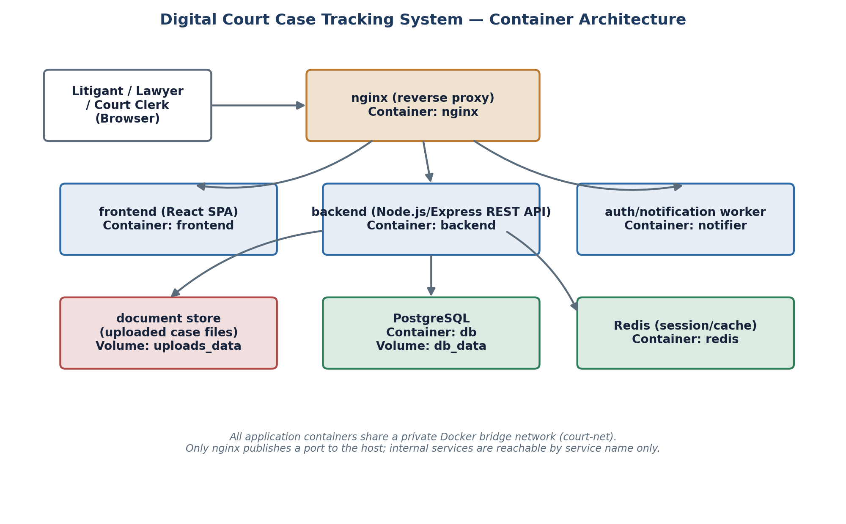
Figure 2 — Container architecture of the Digital Court Case Tracking System.

8. Dockerfile Development

8.1 Backend Dockerfile (backend/Dockerfile)
# ---- Build stage ----
FROM node:20-alpine AS build
WORKDIR /app
COPY package*.json ./
RUN npm ci --omit=dev
COPY src ./src

# ---- Runtime stage ----
FROM node:20-alpine
WORKDIR /app
ENV NODE_ENV=production
COPY --from=build /app /app
RUN addgroup -S appgroup && adduser -S appuser -G appgroup
USER appuser
EXPOSE 4000
HEALTHCHECK --interval=30s --timeout=5s CMD wget -qO- http://localhost:4000/health || exit 1
CMD ["node", "src/server.js"]

8.2 Frontend Dockerfile (frontend/Dockerfile)
# ---- Build stage ----
FROM node:20-alpine AS build
WORKDIR /app
COPY package*.json ./
RUN npm ci
COPY . .
RUN npm run build

# ---- Serve stage ----
FROM nginx:1.27-alpine
COPY --from=build /app/build /usr/share/nginx/html
EXPOSE 80
CMD ["nginx", "-g", "daemon off;"]

8.3 Instruction-by-Instruction Explanation
Instruction | Purpose
FROM ... AS build | Starts a multi-stage build; the build stage contains dev tooling that is discarded from the final image.
WORKDIR | Sets the working directory inside the container for all subsequent instructions.
COPY package*.json ./ | Copies only the dependency manifest first so Docker can cache the npm install layer separately from source code changes.
RUN npm ci --omit=dev | Performs a clean, reproducible dependency install and excludes development-only packages from the runtime image.
COPY --from=build | Copies just the compiled output (backend source / frontend build folder) into a fresh, minimal final image, keeping it small.
RUN addgroup/adduser + USER | Creates and switches to a non-root user so the container does not run as root, reducing the impact of a container compromise.
EXPOSE | Documents which port the container listens on (does not itself publish the port).
HEALTHCHECK | Lets Docker/Compose detect whether the backend API is actually serving requests, not just running.
CMD | Defines the default command executed when the container starts.

9. Docker Compose Design

9.1 docker-compose.yml
version: "3.9"

services:
nginx:
image: nginx:1.27-alpine
ports:
- "8080:80"
volumes:
- ./nginx/nginx.conf:/etc/nginx/conf.d/default.conf:ro
depends_on:
- frontend
- backend
networks:
- court-net

frontend:
build: ./frontend
expose:
- "80"
networks:
- court-net

backend:
build: ./backend
expose:
- "4000"
env_file: .env
environment:
- DB_HOST=db
- REDIS_HOST=redis
volumes:
- uploads_data:/app/uploads
depends_on:
- db
- redis
networks:
- court-net

db:
image: postgres:16-alpine
environment:
- POSTGRES_DB=court_tracker
- POSTGRES_USER=${DB_USER}
- POSTGRES_PASSWORD=${DB_PASSWORD}
volumes:
- db_data:/var/lib/postgresql/data
- ./database/init.sql:/docker-entrypoint-initdb.d/init.sql:ro
networks:
- court-net

redis:
image: redis:7-alpine
networks:
- court-net

volumes:
db_data:
uploads_data:

networks:
court-net:
driver: bridge

9.2 Services, Networking, Volumes, and Dependencies
Element | Explanation
Services | Five services — nginx, frontend, backend, db, redis — each built or pulled independently and orchestrated as one application stack.
Networking (court-net) | A private bridge network lets containers resolve each other by service name (e.g. backend connects to db, not a hard-coded IP); only nginx is published to the host.
Volumes (db_data, uploads_data) | Named volumes persist PostgreSQL data and uploaded case documents outside the container lifecycle, so data survives a container rebuild or restart.
Environment variables | Database credentials and host names are injected via .env / environment:, keeping secrets out of the image and out of Git.
depends_on | Ensures the backend only starts after db and redis are scheduled, and nginx only starts after frontend and backend, reflecting real startup order requirements.
Bind mounts (config files) | nginx.conf and init.sql are mounted read-only from the host so configuration can be changed without rebuilding an image.

10. Container Deployment and Testing

10.1 Building and Running the Stack
$ cp .env.example .env # fill in DB_USER / DB_PASSWORD
$ docker compose build
$ docker compose up -d

$ docker compose ps
NAME STATUS PORTS
court-case-tracker-nginx Up 12 seconds 0.0.0.0:8080->80/tcp
court-case-tracker-frontend Up 13 seconds (healthy) 80/tcp
court-case-tracker-backend Up 13 seconds (healthy) 4000/tcp
court-case-tracker-db Up 14 seconds 5432/tcp
court-case-tracker-redis Up 14 seconds 6379/tcp

10.2 Functional Testing Procedure
- Health check: curl http://localhost:8080/api/health returns {"status":"ok"}, confirming nginx correctly proxies to the backend container.
- Case registration: POST /api/cases with a sample case payload returns HTTP 201 and a generated case number; verified against the database using docker compose exec db psql.
- Case search: GET /api/cases/CASE-2026-0142 returns the current stage and next hearing date, confirming the frontend's search page renders correctly end-to-end.
- Hearing scheduling: POST /api/hearings creates a hearing linked to a case and confirms the audit-log middleware recorded the change with a timestamp and actor.
- Restart resilience: docker compose restart db followed by a repeat of the search query confirms data in the db_data volume survives a container restart.

10.3 Evidence of Successful Execution
Deliverable screenshots captured alongside this report (see the accompanying screenshot pack) include: the output of docker compose ps showing all five services healthy; a browser screenshot of the case-search page returning live data from the backend; the terminal output of the curl health-check call; and a docker compose logs backend excerpt showing an incoming request being logged and served with a 200 response.
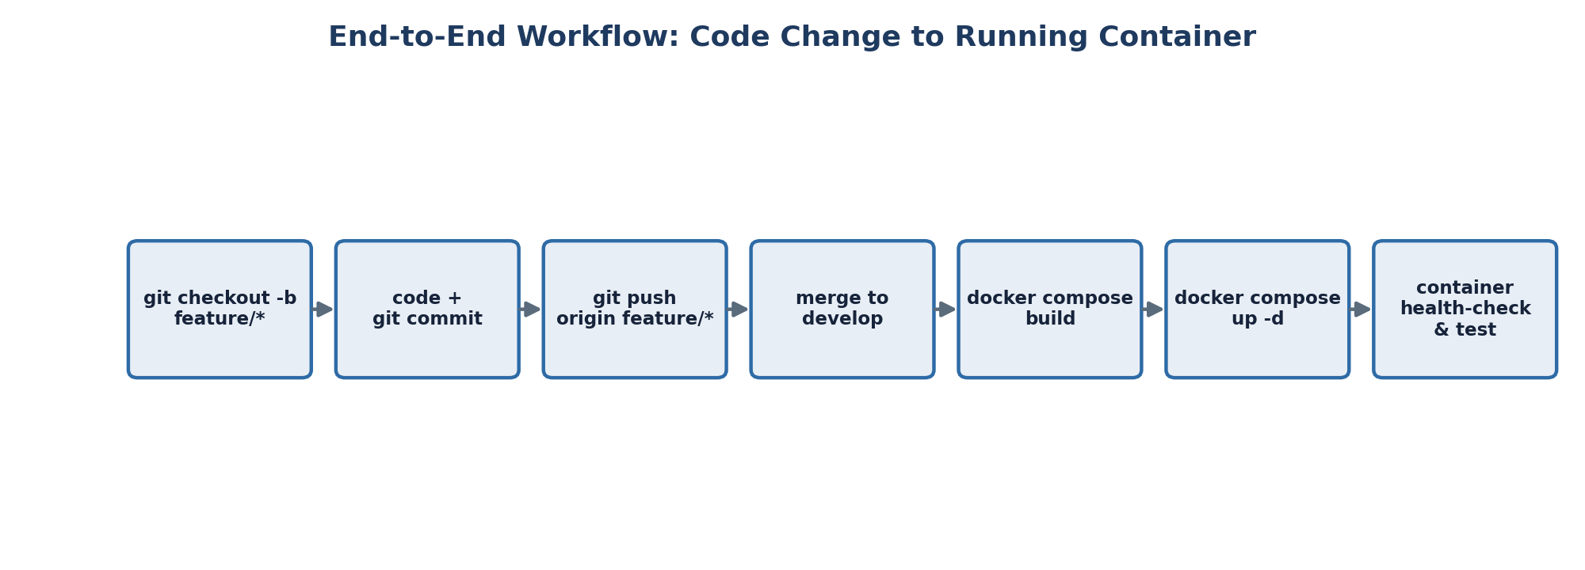
Figure 3 — End-to-end workflow from a code change to a running, tested container.

11. Benefits of Git and Docker
Benefit | How it applies to the Court Case Tracker
Collaboration | Git branches let backend, frontend, and database work happen in parallel and be reviewed through pull requests before reaching develop or main.
Version management | Every schema change, API change, and UI change is traceable to a specific commit and author, which matters for a system whose data integrity may be legally significant.
Portability | Docker images run the same way on a developer laptop, the CI runner, and a court's on-premise server, regardless of the underlying OS.
Deployment | docker compose up gives a one-command, repeatable deployment instead of a multi-page manual installation guide for court IT staff.
Scalability | Because backend and frontend are separate, stateless containers, the backend can be scaled to multiple replicas behind nginx during peak filing periods without touching the frontend or database.
Maintainability | Small, well-labelled commits plus isolated, single-purpose containers make it far easier to patch, roll back, or audit one component without destabilising the whole system.

12. Challenges and Improvements

12.1 Challenges Encountered
- Merge conflicts occurred when two feature branches both modified the shared server.js route-registration file; resolved manually as shown in Section 5.3, but highlighted the need for clearer module boundaries.
- Managing database credentials safely: an early draft accidentally referenced a hard-coded password in docker-compose.yml, which was corrected by moving all secrets into an untracked .env file referenced via env_file.
- Container startup ordering: depends_on only waits for a container to start, not for PostgreSQL to be ready to accept connections, which caused the backend to fail on its first boot; this was mitigated with the container HEALTHCHECK and an application-level retry/backoff on the database connection.
- Keeping the Docker image small: an early backend image bundled devDependencies and test files, roughly tripling image size, until the multi-stage build in Section 8.1 was introduced.

12.2 Suggested Improvements and Future Enhancements
- Add a CI/CD pipeline (e.g. GitHub Actions) that automatically runs tests and builds images on every push to develop, and only allows a merge to main after checks pass.
- Introduce a proper database migration tool (e.g. node-pg-migrate) instead of a single init.sql, so schema changes can be versioned and rolled back independently of Git history.
- Move from Docker Compose to a lightweight orchestrator (e.g. Docker Swarm or Kubernetes) if the system needs to run across multiple physical nodes for court-wide high availability.
- Add centralized logging and monitoring (e.g. an ELK or Grafana/Loki stack) so audit-trail and performance data from all containers can be reviewed from one dashboard.
- Extend role-based access control with multi-factor authentication for judge and admin accounts, given the sensitivity of case records.

